Name:Teja Simha Reddy
Workshop Replication

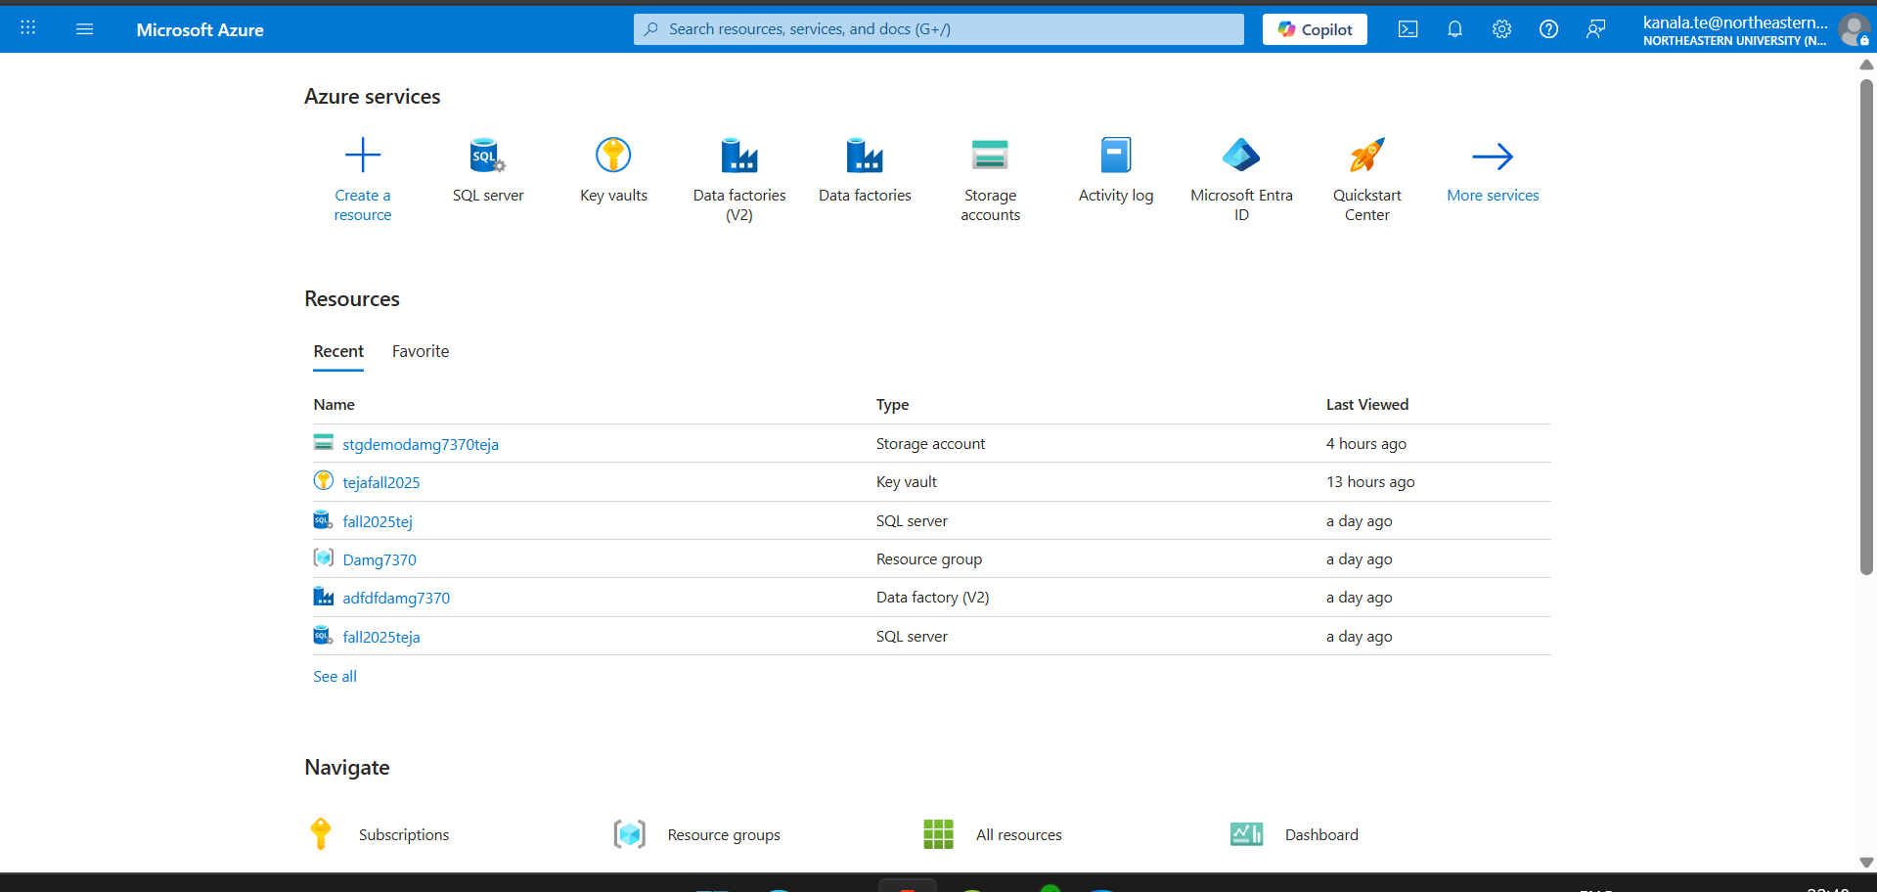

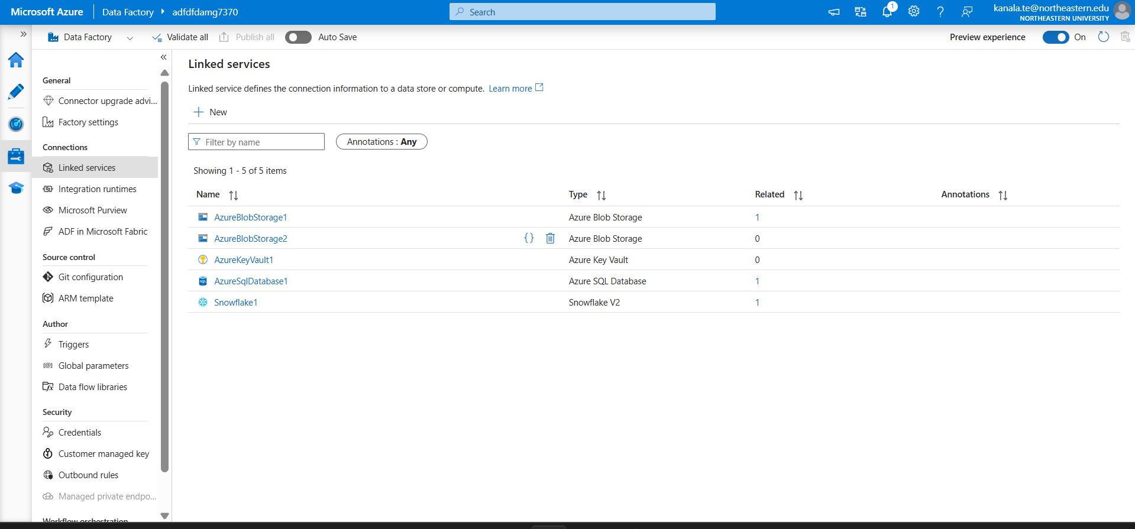
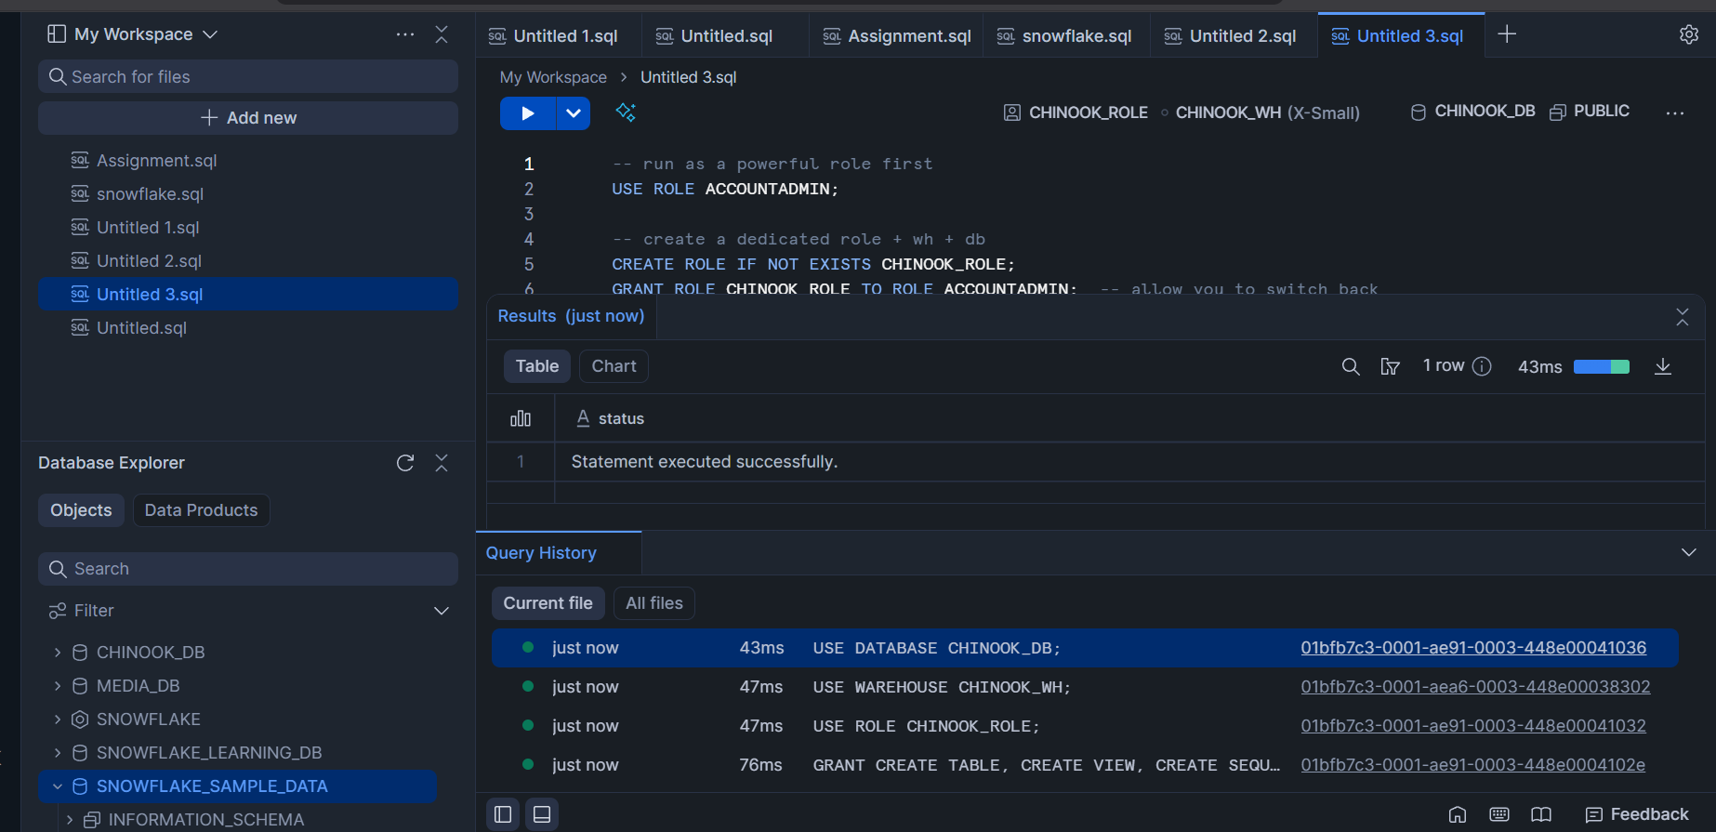
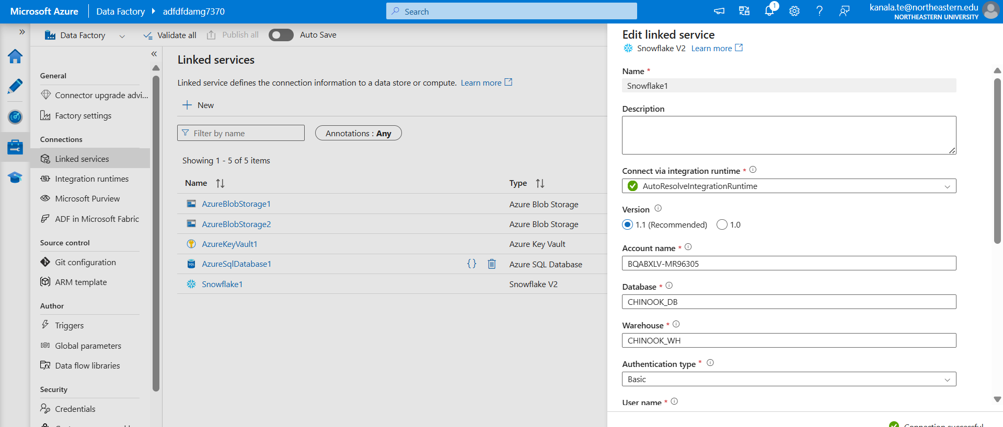

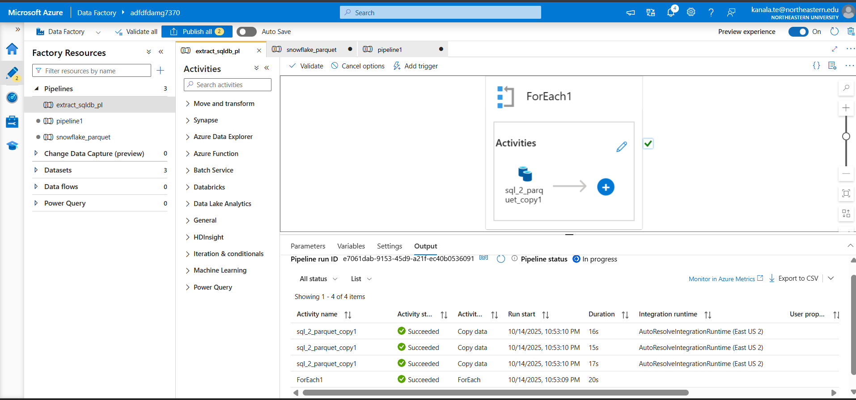
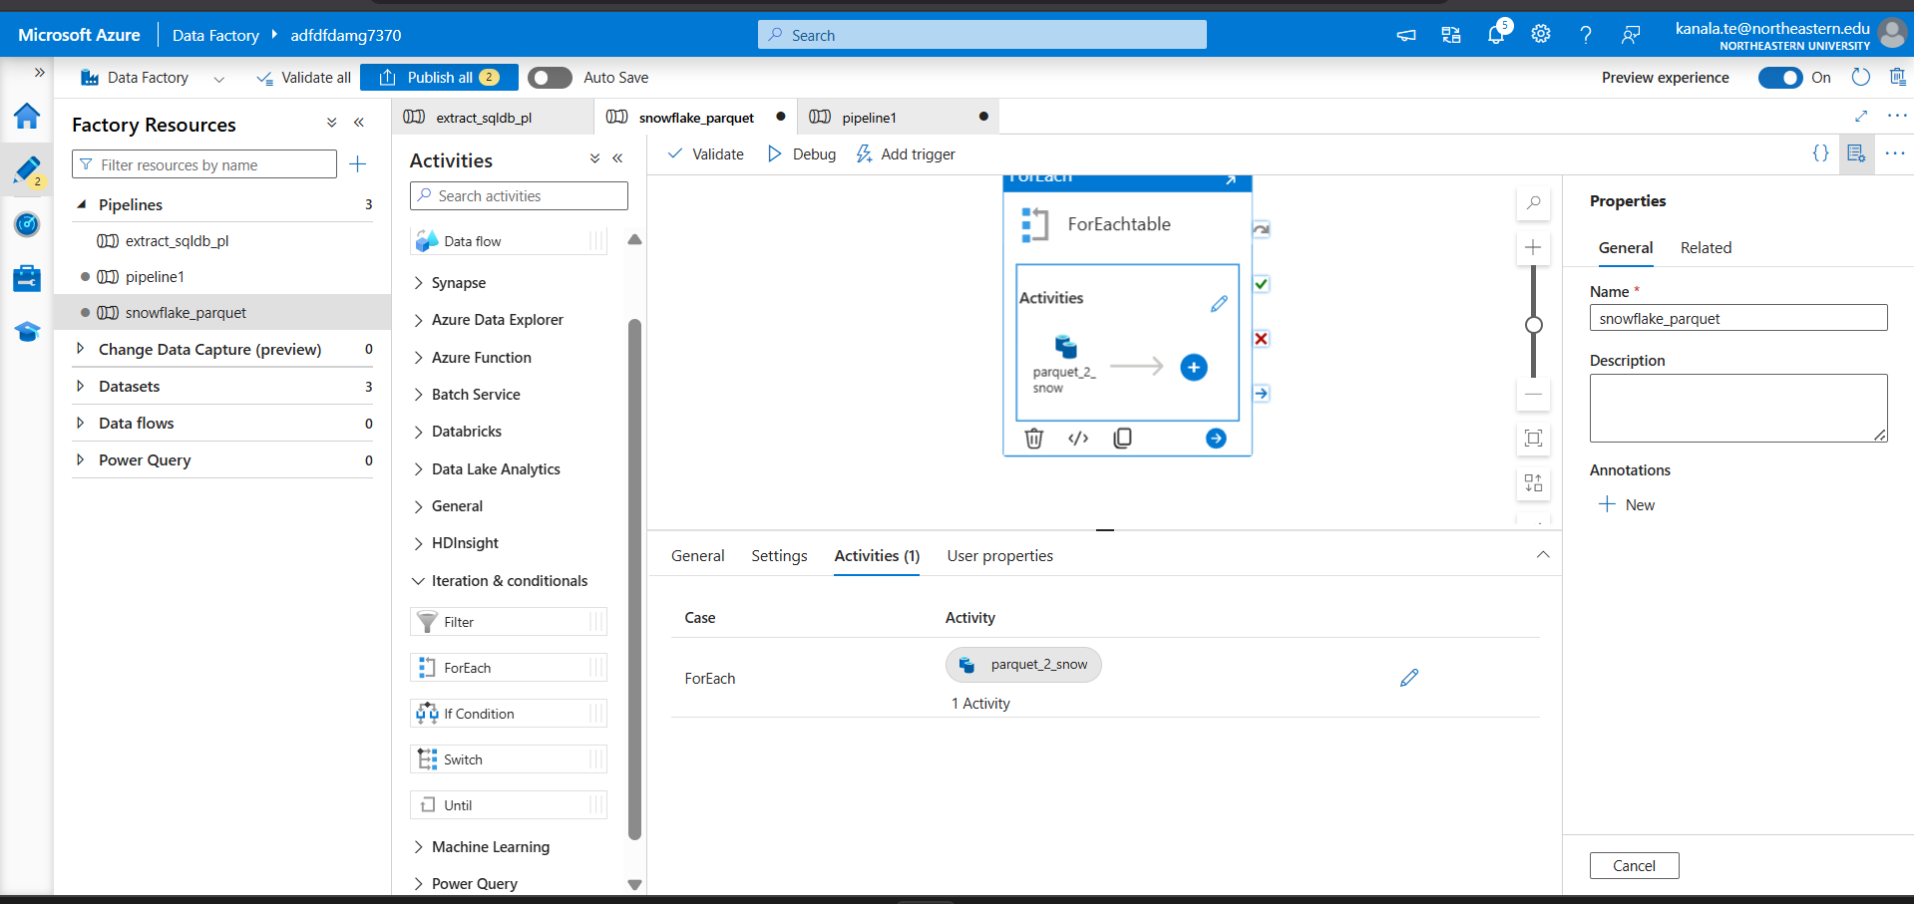
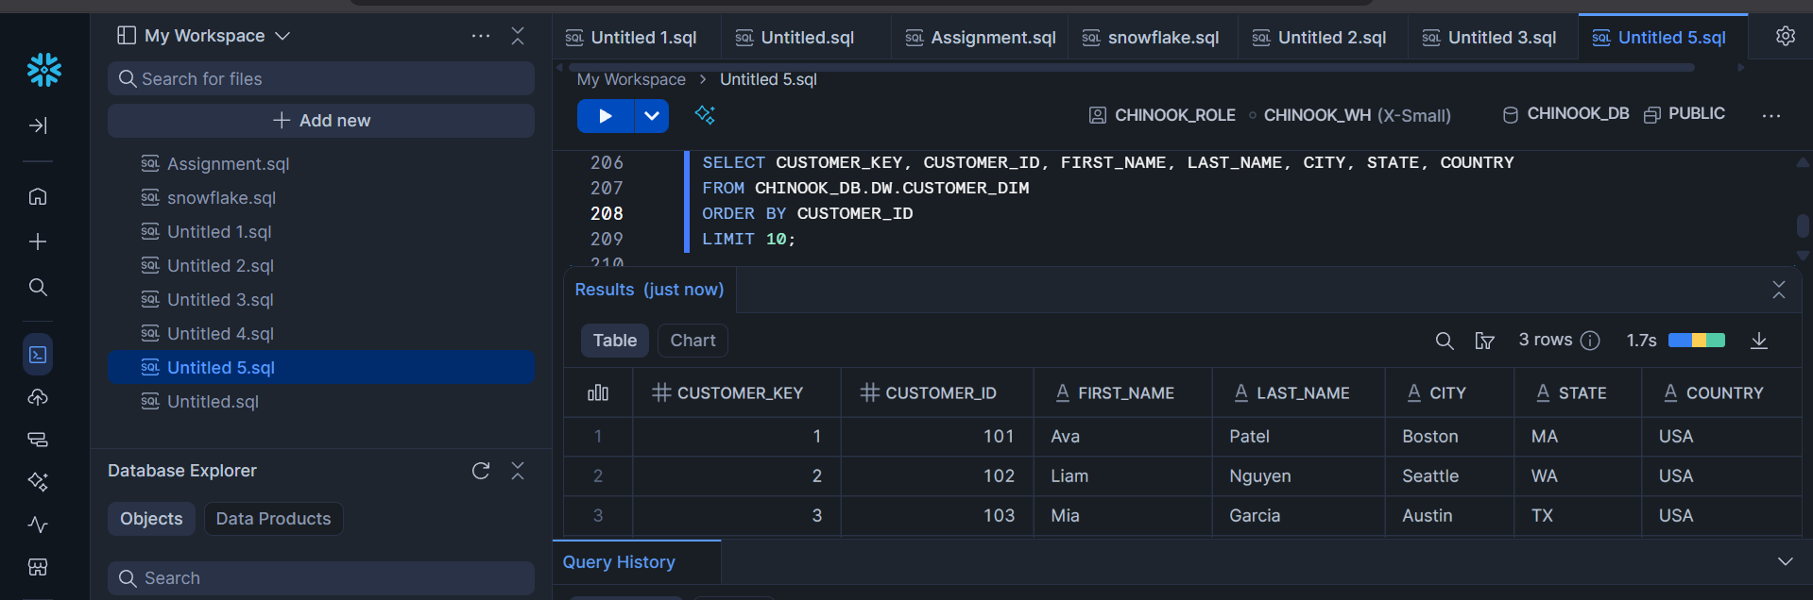

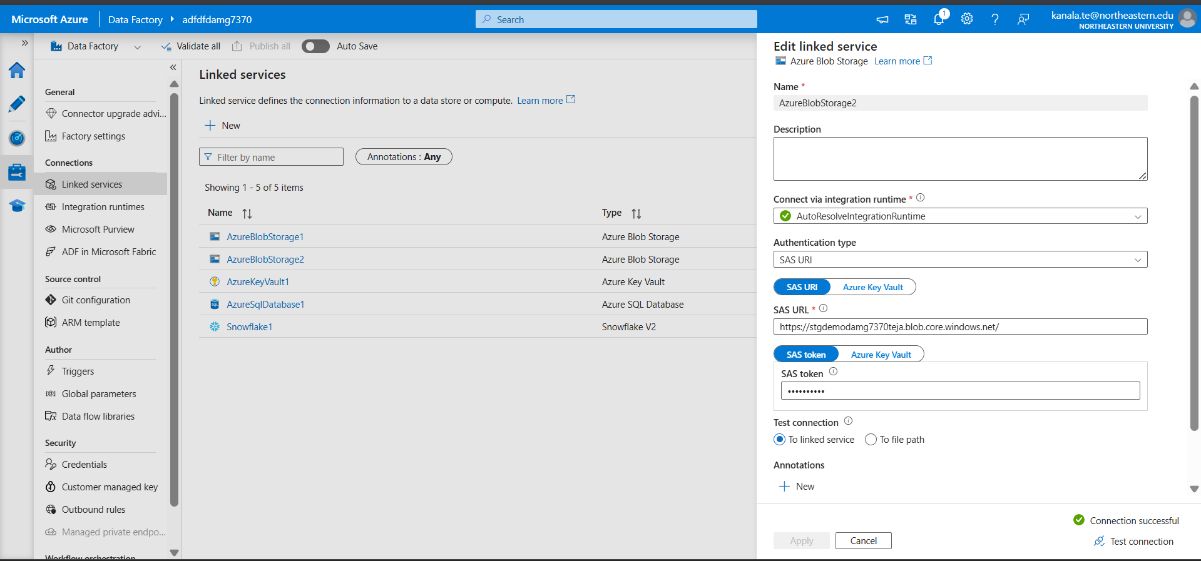

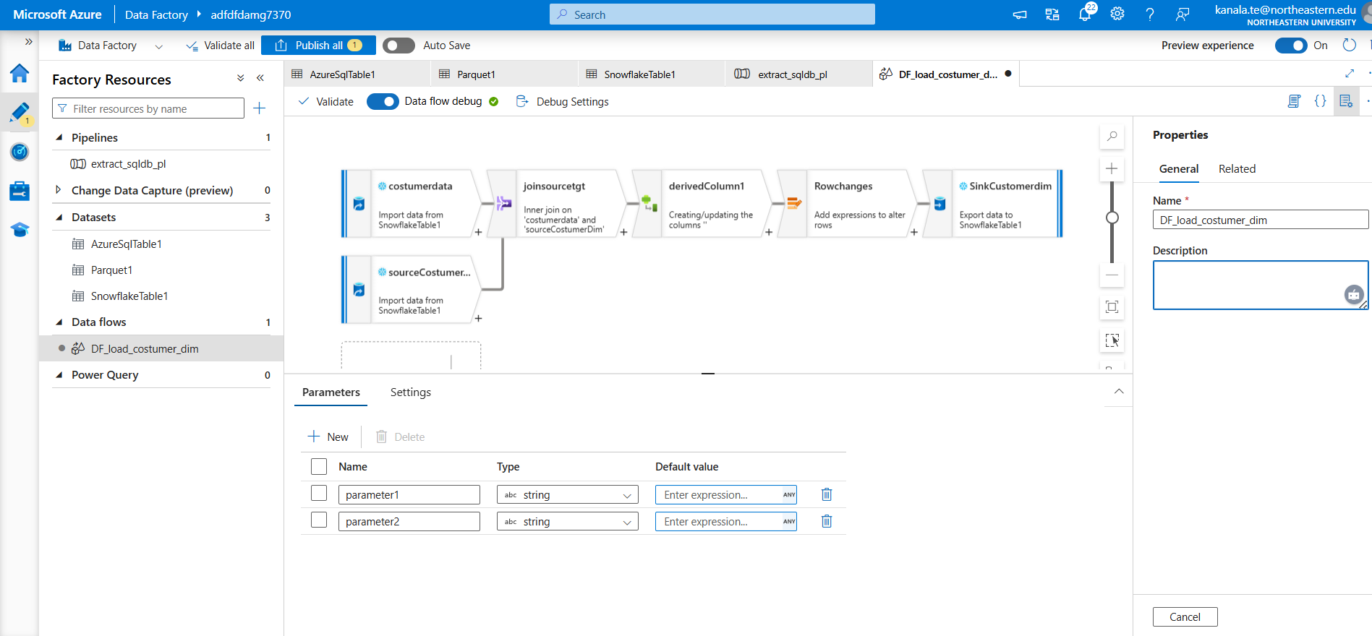

Core DW Tables (with sequences and hash column)
-- DATE_DIM
CREATE OR REPLACE TABLE DW.DATE_DIM (
DATE_KEY NUMBER(10) PRIMARY KEY, -- yyyymmdd
FULL_DATE DATE,
DAY_NUM NUMBER(3),
WEEKDAY_ABBR VARCHAR(3),
WEEKDAY_NUM NUMBER(1),
DAY_OF_YEAR_NUM NUMBER(3),
WEEK_OF_YEAR NUMBER(2),
MONTH_NUM NUMBER(2),
MONTH_ABBR VARCHAR(3),
QUARTER_NUM NUMBER(1),
QUARTER_NAME VARCHAR(3),
YEAR_NUM NUMBER(4),
FIRST_DAY_OF_MONTH DATE,
LAST_DAY_OF_MONTH DATE,
IS_WEEKEND VARCHAR(1)
);

-- TIME_DIM
CREATE OR REPLACE TABLE DW.TIME_DIM (
TIME_KEY NUMBER(4) PRIMARY KEY, -- HHMM (0000..2359)
HOUR_NUM INTEGER,
MINUTE_NUM INTEGER,
TIME_24_HR STRING
);

-- CUSTOMER_DIM (adds HASH column for change detection)
CREATE OR REPLACE TABLE DW.CUSTOMER_DIM (
CUSTOMER_KEY NUMBER(10) PRIMARY KEY,
CUSTOMER_ID NUMBER(10),
FIRST_NAME VARCHAR(100),
LAST_NAME VARCHAR(100),
COMPANY_NAME VARCHAR(100),
CITY VARCHAR(100),
STATE VARCHAR(50),
COUNTRY VARCHAR(50),
ZIP_CODE VARCHAR(10),
EMPLOYEE_ID NUMBER(10),
IS_ACTIVE VARCHAR(1) DEFAULT 'Y',
SOURCE_ID VARCHAR(50),
DATE_TO_WAREHOUSE TIMESTAMP DEFAULT CURRENT_TIMESTAMP(),
CUSTOMER_HASH_VAL VARCHAR(128) -- SHA-256 hex
);

CREATE OR REPLACE SEQUENCE CUSTOMER_DIM_SEQ START = 1 INCREMENT = 1;

-- ARTIST_DIM
CREATE OR REPLACE TABLE DW.ARTIST_DIM (
ARTIST_KEY NUMBER(10) PRIMARY KEY,
ARTIST_ID NUMBER(10),
ARTIST_NAME VARCHAR(150),
SOURCE_ID VARCHAR(50),
DATE_TO_WAREHOUSE TIMESTAMP DEFAULT CURRENT_TIMESTAMP()
);

CREATE OR REPLACE SEQUENCE ARTIST_DIM_SEQ START = 1 INCREMENT = 1;

-- SALES_FACT (references DATE_DIM_KEY instead of raw date)
CREATE OR REPLACE TABLE DW.SALES_FACT (
SALES_KEY NUMBER(10) PRIMARY KEY,
CUSTOMER_KEY NUMBER(10),
INVOICE_ID NUMBER(10),
DATE_DIM_KEY NUMBER(10),
TOTAL_SALE_AMT NUMBER(10,2),
SOURCE_ID NUMBER(10),
DATE_TO_WAREHOUSE TIMESTAMP DEFAULT CURRENT_TIMESTAMP()
);

CREATE OR REPLACE SEQUENCE SALES_FACT_SEQ START = 1 INCREMENT = 1;

